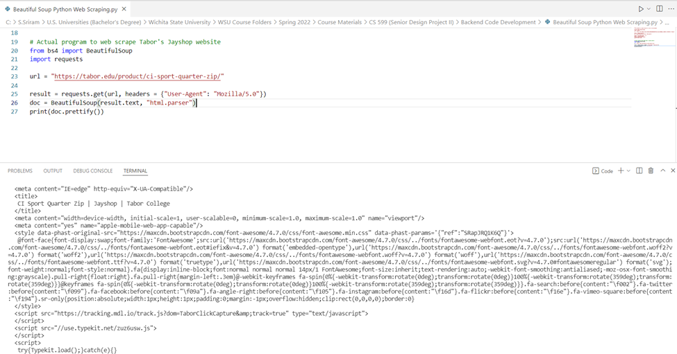

Figure 1 - web scraping information from Tabor College works

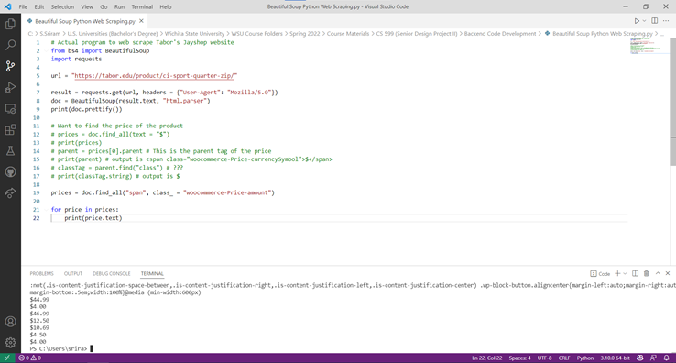Figure 2 - successful in scraping the prices of various products from Tabor’s JayShop website